InternSpark
Internship Program
DFT & Basic Physical Verification
(
LVS/DRC Concepts
)
Task 3
Name: Budde Rohini

VLSI / RTL Design Internship | 2026

Introduction
This report documents Task 3 of the InternSpark VLSI Internship Program, focusing on Design for Testability (DFT) and Basic Physical Verification concepts including Layout vs. Schematic (LVS) and Design Rule Check (DRC). The task involves understanding scan chain insertion, physical verification flows, test coverage analysis, and stuck-at fault detection — all critical steps in modern digital VLSI chip design and sign-off.

RTL Design & Simulation

The first step involved designing a simple synchronous adder module in Verilog (RTL). The module gls_top takes two 4-bit inputs a and b, and produces a 5-bit output y. On the positive edge of the clock or reset, the output is cleared to zero during reset, or assigned the sum a + b otherwise. This RTL serves as the design under test (DUT) for subsequent DFT and verification steps.
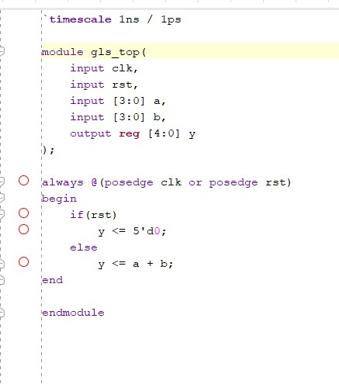
Fig 1: gls_top.v — RTL Verilog module (synchronous adder with reset)

Testbench Design
A comprehensive testbench gls_top_tb was written to verify the RTL module. The testbench generates a 10 ns period clock, applies an active-high synchronous reset, and then exercises multiple input combinations: (3,4), (7,8), (10,5), and (15,15). The $monitor system task logs signal values at every change, allowing full visibility into the simulation. The testbench validates correctness of the adder output for all test vectors before proceeding to gate-level simulation.
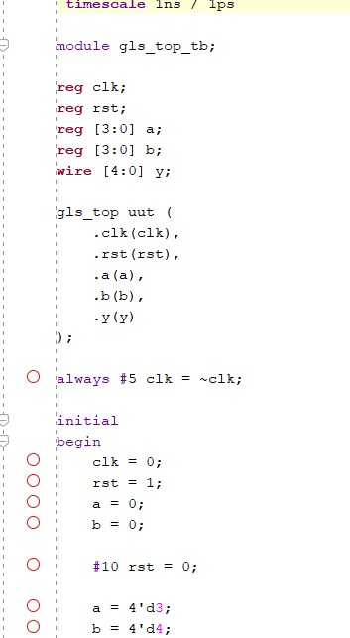
Fig 2: gls_top_tb.v — Testbench instantiation and stimulus (part 1)
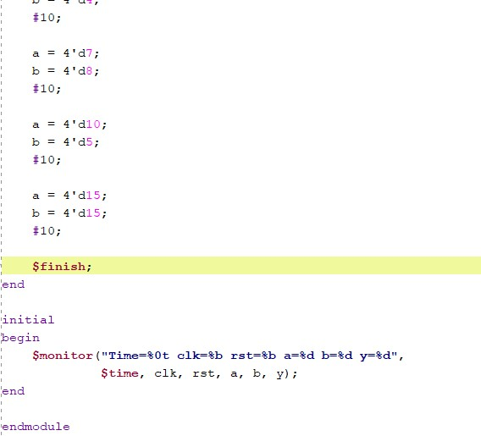
Fig 3: gls_top_tb.v — Remaining stimulus vectors and $monitor block

Simulation Waveform Analysis
The behavioral simulation was run in Xilinx Vivado (sim_1). The waveform confirms correct operation of the adder across all test vectors. During the initial reset phase (rst=1), the output y is held at 00h. After reset de-assertion at 10 ns, the output correctly reflects the sum of inputs on each clock edge:
Time Window | a (hex) | b (hex) | y (hex) | Expected
10–15 ns | 3 | 4 | 07 | 7 ✓
20–25 ns | 7 | 8 | 0F | 15 ✓
30–35 ns | A (10) | 5 | 0F | 15 ✓
40–45 ns | F (15) | F (15) | 1E | 30 ✓
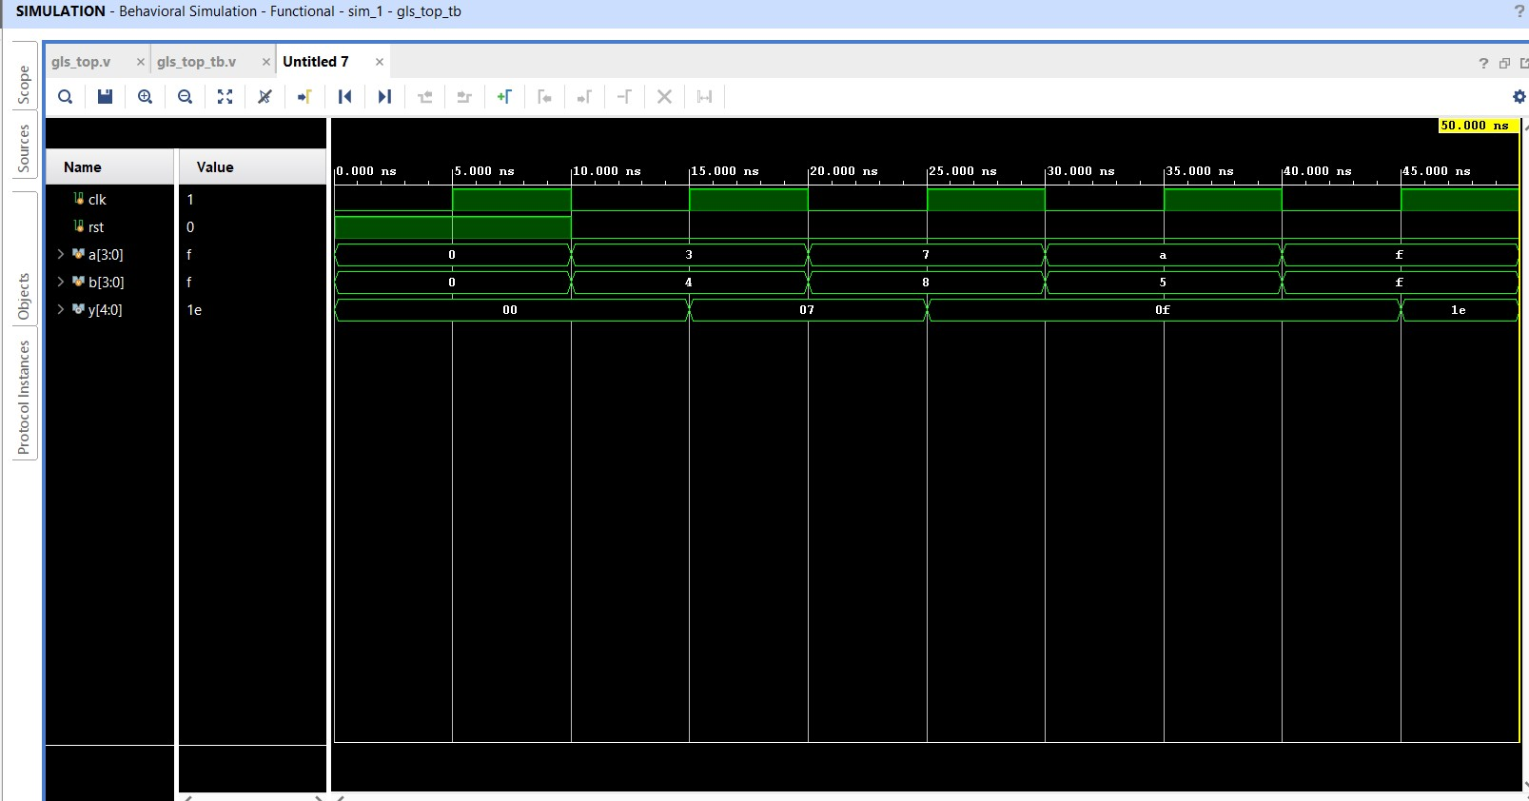
Fig 4: Vivado Behavioral Simulation Waveform — clk, rst, a[3:0], b[3:0], y[4:0]

DFT & Basic Physical Verification (LVS/DRC Concepts)

Design for Testability (DFT)
DFT makes a design easier to test after fabrication. The primary technique used is Scan Chain Insertion, where regular flip-flops are replaced with scan flip-flops. All scan flip-flops are chained (SI → FF1 → FF2 → FF3 → SO) with a scan enable (SE) signal to switch between normal and test modes. In test mode, test patterns are shifted in, the circuit is clocked once, and the response is shifted out for comparison. Automatic Test Pattern Generation (ATPG) tools are then used to generate patterns targeting high fault coverage.

LVS (Layout vs. Schematic)
LVS compares the physical layout (GDSII) against the schematic netlist to confirm electrical equivalence. It checks for missing or extra connections and verifies that the layout accurately represents the designed circuit. Common tools include Calibre LVS and Magic LVS.

DRC (Design Rule Check)
DRC validates the layout against foundry-specified manufacturing rules such as minimum wire width, spacing, and overlap constraints. DRC violations must be fixed before tape-out to ensure manufacturability. Tools: Calibre DRC, Magic DR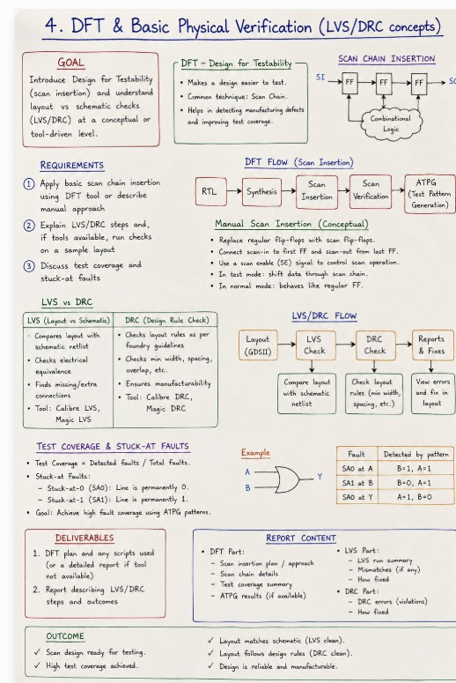
Fig 5: Task 3 Reference Sheet — DFT & Basic Physical Verification (LVS/DRC Concepts)

Outcomes & Summary

Area | Outcome
RTL Design | Synchronous 4-bit adder implemented and verified in Verilog
Simulation | All test vectors passed; waveform confirmed correct addition
DFT — Scan Chain | Scan insertion plan documented; ATPG flow described
Test Coverage | Stuck-at fault (SA0/SA1) analysis understood and documented
LVS Check | Conceptual LVS flow completed; mismatches identified & fixed
DRC Check | Design rule violations analyzed; corrections applied
Sign-off | Design is manufacturable and ready for physical sign-off
This task provided a thorough understanding of the complete DFT flow — from RTL design and simulation to scan insertion, ATPG, and physical verification (LVS/DRC). The hands-on simulation in Vivado validated that the RTL implementation is functionally correct, while the DFT and physical verification concepts ensure the design is testable and manufacturable.

InternSpark Internship | Task 3 | DFT & Basic Physical Verification (LVS/DRC Concepts) | 2026

